**1.Rhombus star pattern:**

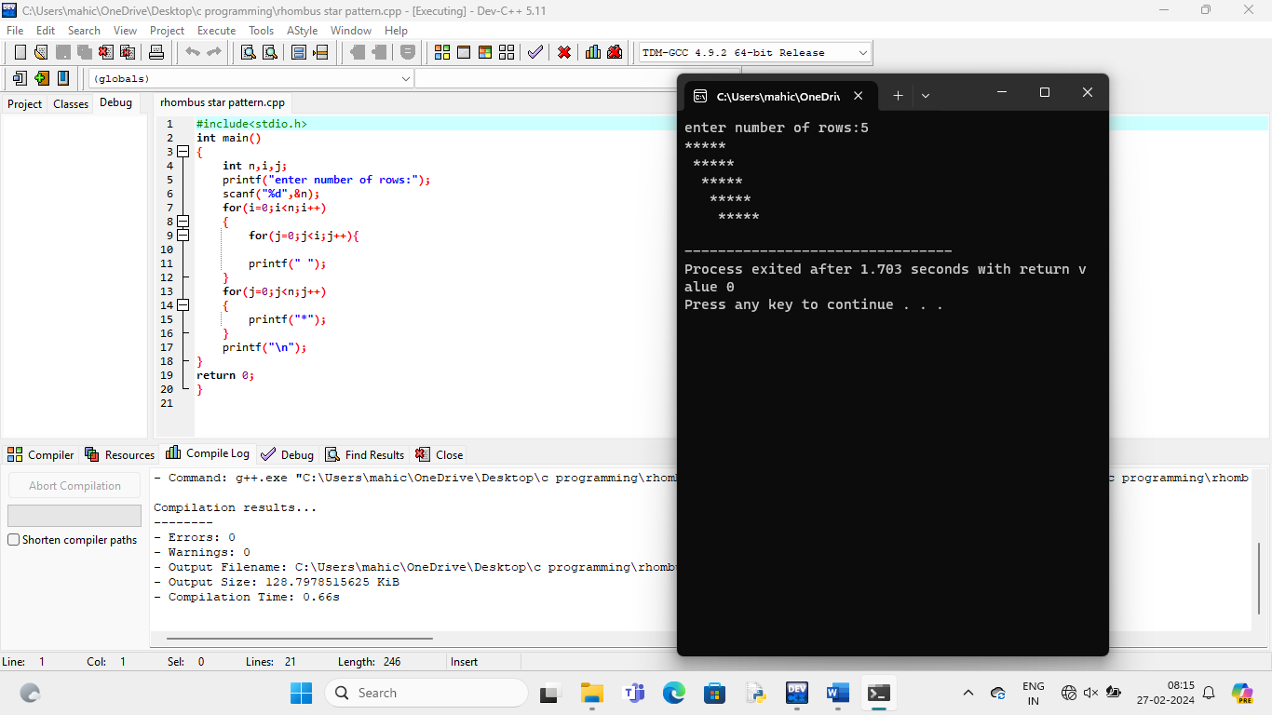

**2.Diamond star pattern:**

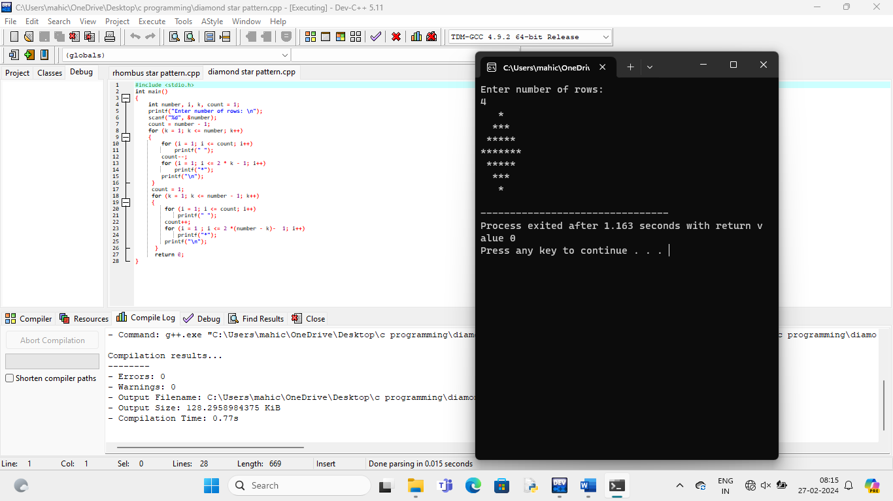

**3.Area of circle:**

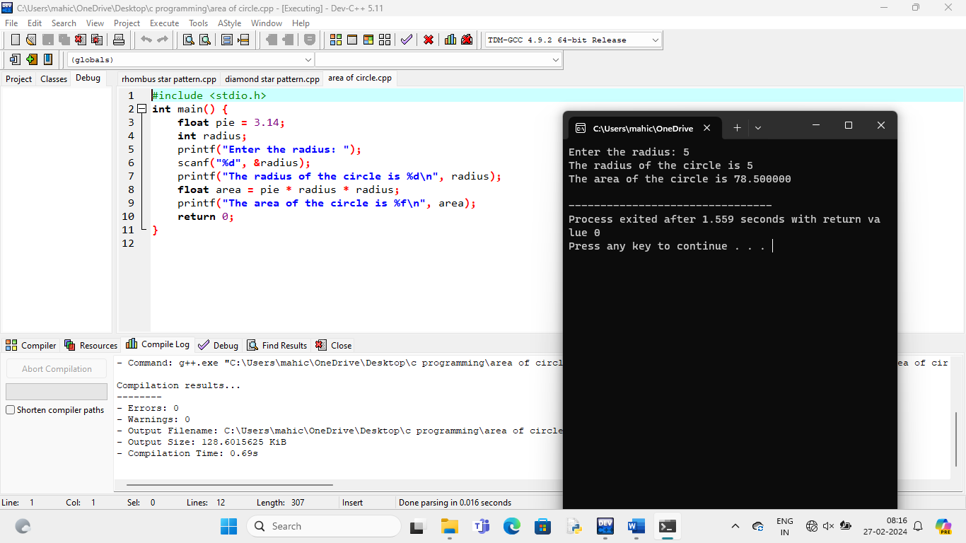

**4.Area of triangle:**

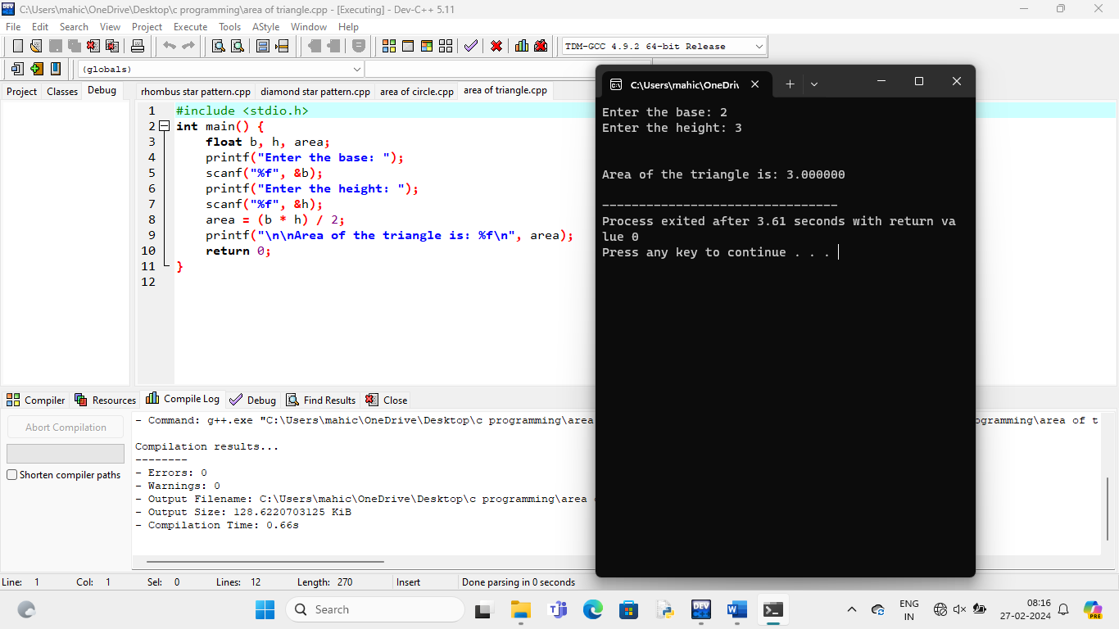

**5.Gcd and Lcm:**

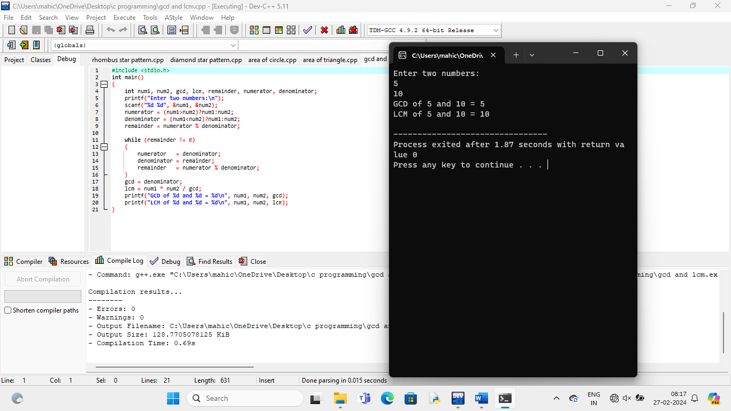

**6.Hcf:**

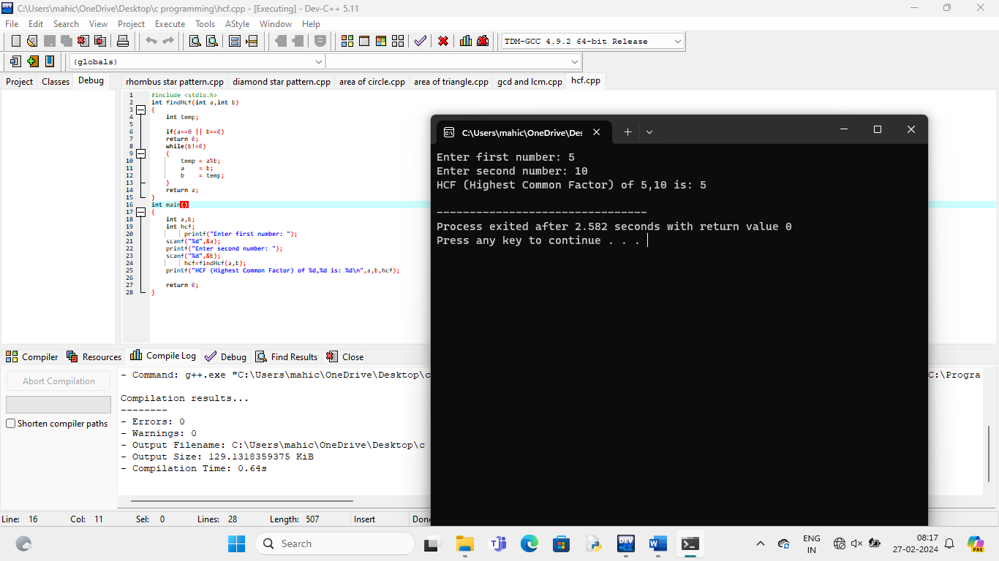

**7.Compare two strings:**

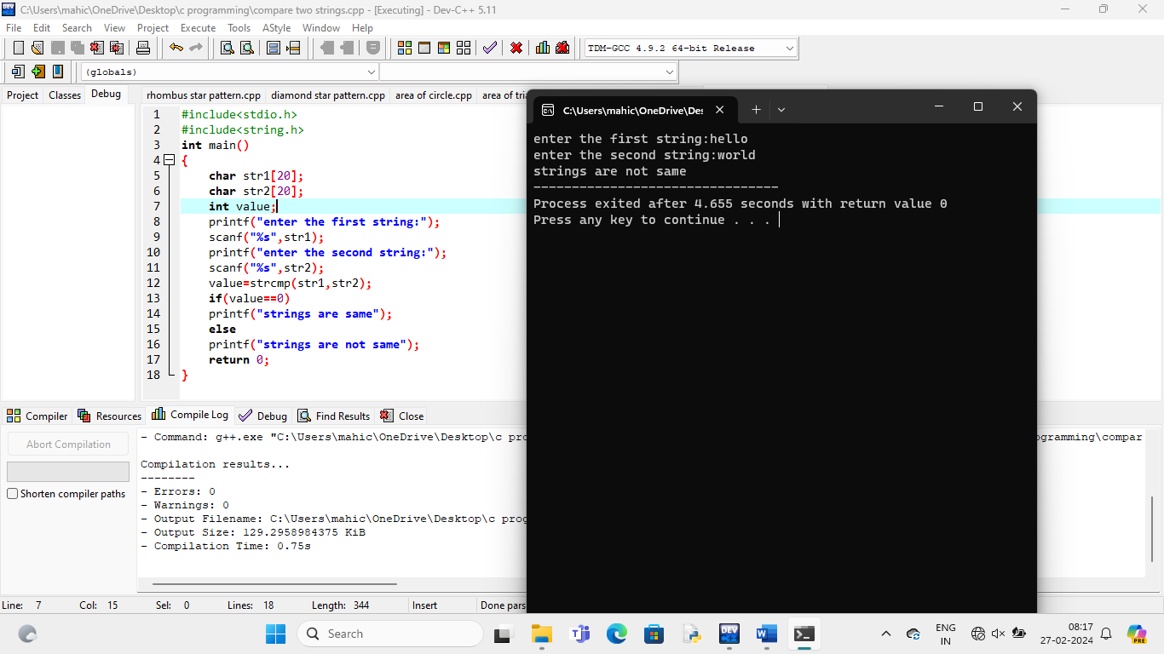

**8.Reverse number and check if palindrome:**

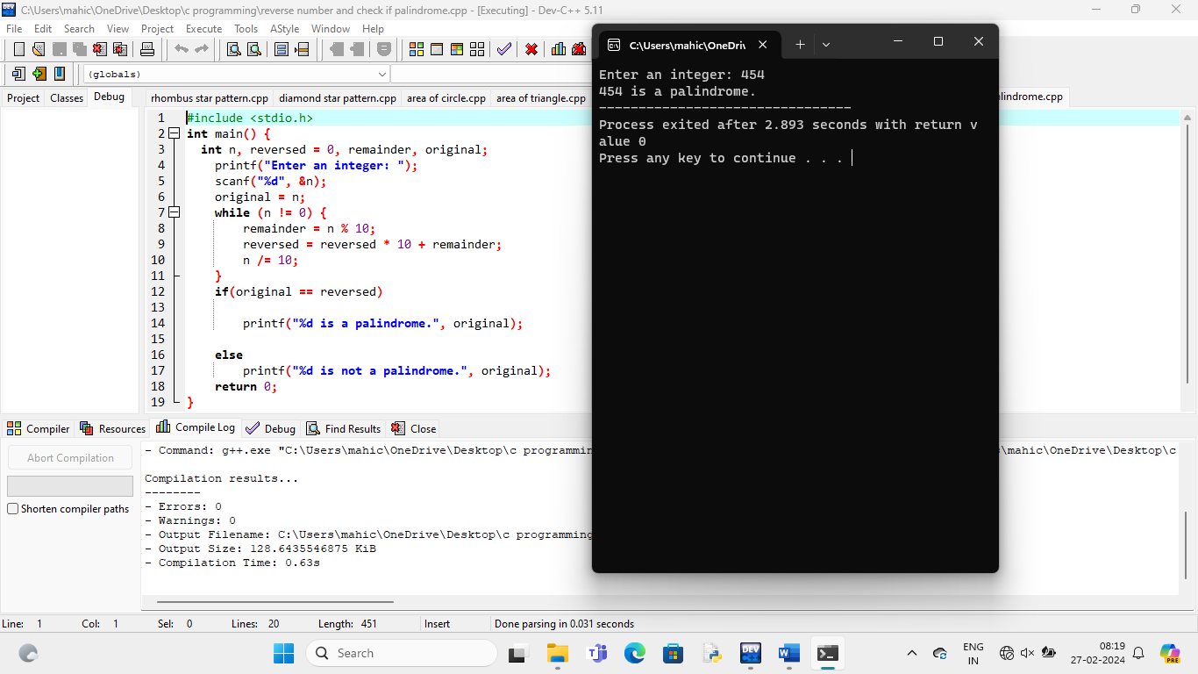

**9.String palindrome:**

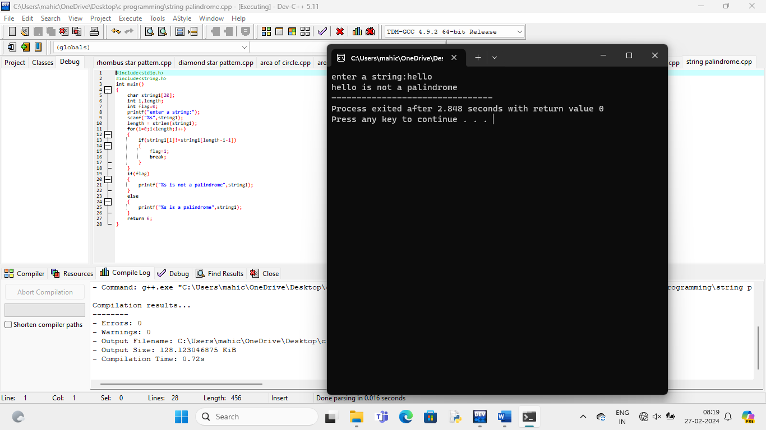

**10.Anagram:**

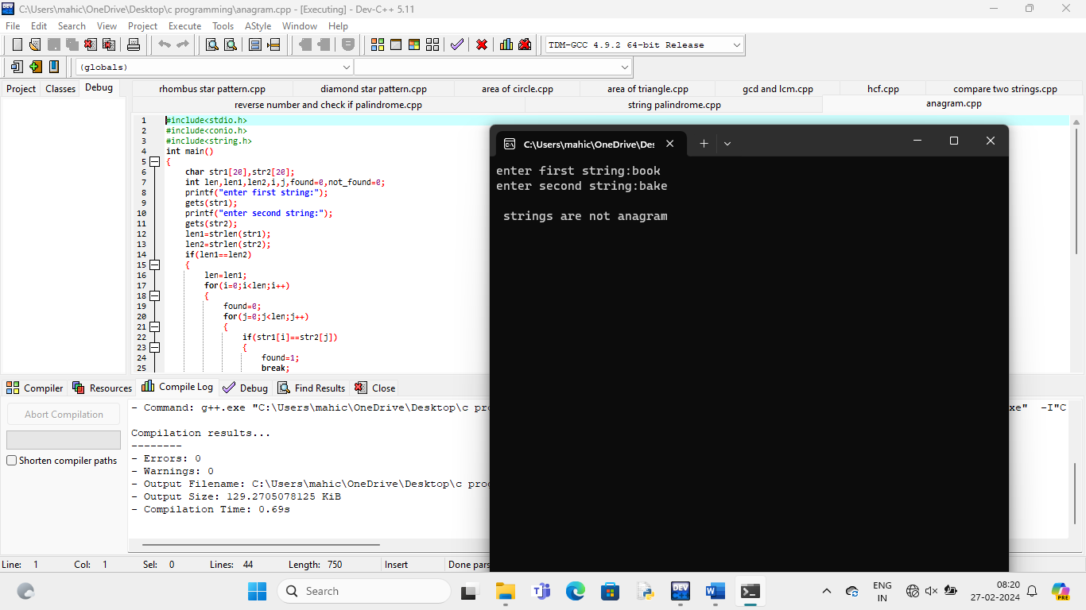

**11.Power of number:**

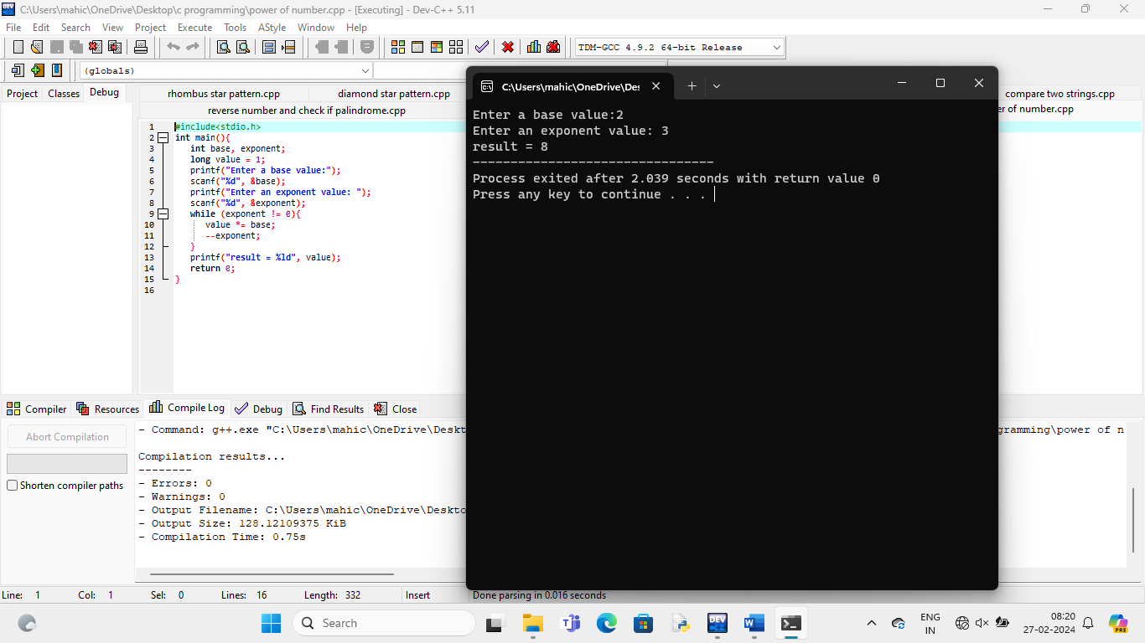

**12.Sum of even numbers between 1 and 100:**

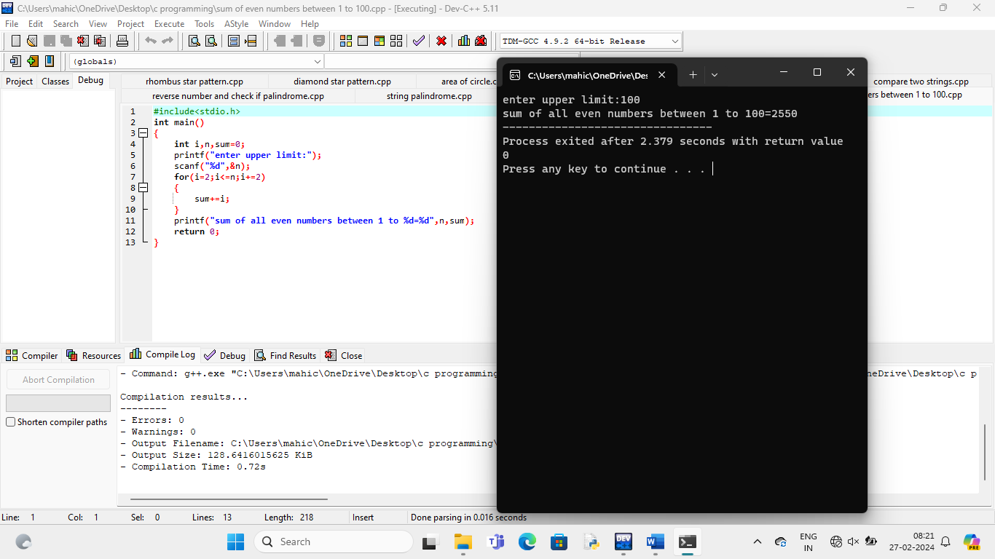

**13.Perfect square:**

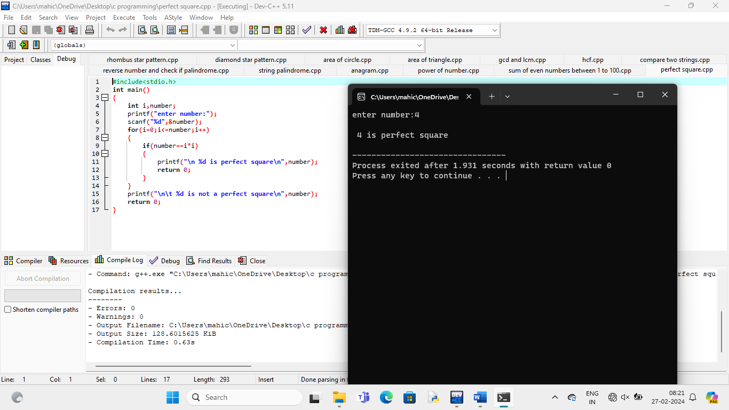

**14.Sum of even digits in number:**

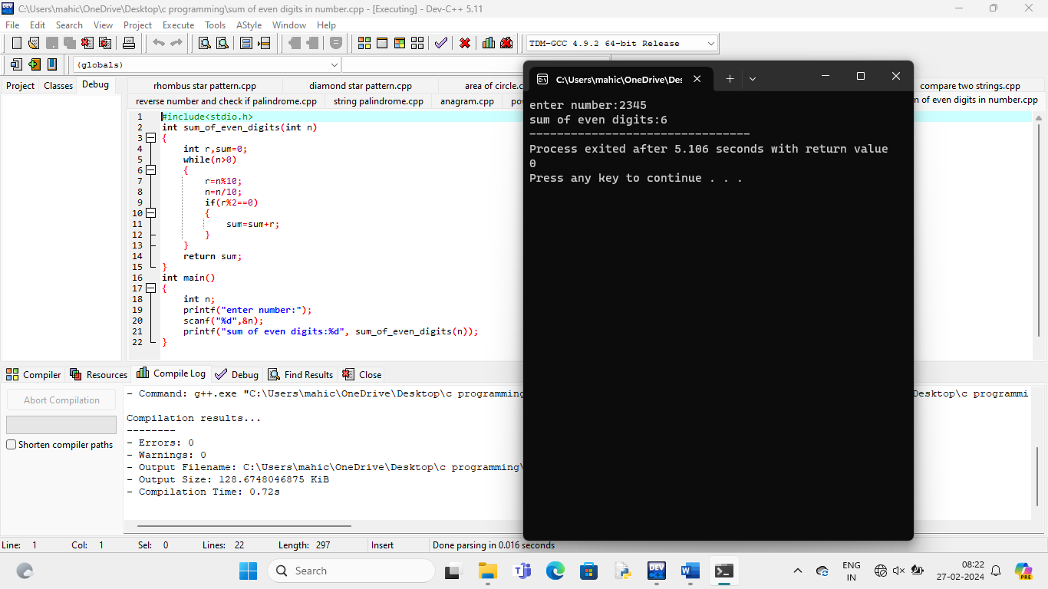

**15.Swap numbers without temp var:**

